Small Group Leader Basics

Copyright © 2015 by General Church Outreach
All rights reserved. No part of this publication may be reproduced or transmitted in any form or by any means, electronic or mechanical, including photocopying, recording, or any information storage or retrieval system, without prior permission from the publisher.
Theme developed by General Church Outreach
Cover Image: iStock Photo
Scriptural quotations are taken from the Holy Bible, New International Version®, NIV®.Copyright © 1973, 1978, 1984 by Biblica, Inc.TM Used by permission of Zondervan. All rights reserved worldwide. www.zondervan.com. Quotations taken from the Holy Bible, New King James Version, are marked NKJV, and quotations taken from the English Standard Version, are marked ESV.
The concepts and teachings in this guide are drawn from the Old and New Testaments and the works of Emanuel Swedenborg. Throughout this book, as is customary in Swedenborgian studies, the numbers following the titles of the works of Emanuel Swedenborg refer to paragraph or section numbers (uniform in all editions) rather than to page numbers. This book utilizes a variety of translations of the Old Testament, New Testament and the works of Emanuel Swedenborg.
The New Church is a new Christianity. Among its teachings are:
- God (the Lord) is love and wisdom, and all life is from the Lord.
- The Bible’s ancient truth is relevant today - truth about how to act with wisdom and love.
- The kingdom of heaven exists within each person.
- The Lord does not condemn anyone to hell.
- Every major religion has teachings similar to the Ten Commandments, and everyone who lives according to his or her conscience is saved.
www.newchurchjourney.org www.facebook.com/NewChurchJourney

“Love to the Lord and caring for the
neighbor make the church”
-Secrets of Heaven 4723
1

Dear friends,

Thank you for your interest in being a small group leader, a host or point person at your church! Your willingness to step up is a blessing to those around you. You will help to create a space where people can connect with each other in a meaningful way and to look to the Lord and make positive change in their lives.

"Heaven consists in desiring from the heart the good of others more than one’s own, and in serving others for the sake of their happiness." (Heaven and Hell 408)

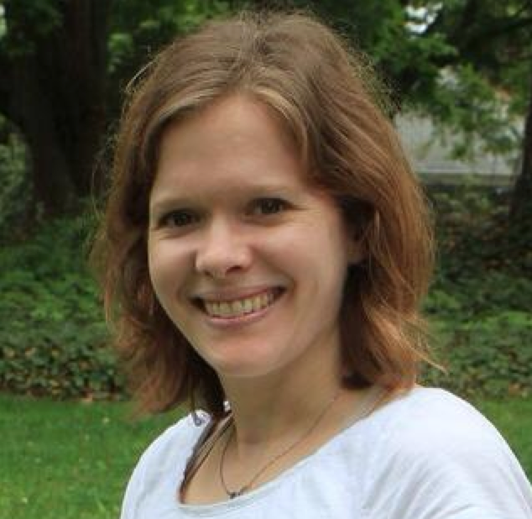
I hope this resource is useful to you as a starting point and that you feel free to innovate to the unique needs/interests of your group.

With gratitude,
Bronwen Henry

General Church Outreach, Journey Program Manager

Visit us at: www.NewChurchJourney.org
Contact us at: campaignteam@newchurch.org
or call 267-502-4916

What is a small group?

A small group is a gathering of people who meet intentionally and regularly to look to the Lord with the goal of offering mutual acceptance, support, and encouragement for one another's life goals and challenges. Basically, there are three main components that make up a small group:

- There is an intentional gathering. This group of people plans where and when to meet and arrange their schedules to be there. They have a purpose for getting together.
- The group meets regularly. A small group has a regular meeting time and schedule. The groups know when to expect their next gathering.
- The group meets for the purpose of looking to the Lord in their lives.

3

Three Easy Steps to Get Started

- Choose your focus
- Invite friends
- Plan your first meeting
- Get support from a Small Group point person

Part 1: Getting Started

So You Want to Lead/Host a Small Group?
Great! Here are some ideas to get you started:

Assess Your Goals As a Leader
Knowing what kind of a leader you are or aspire to be can help you utilize your individual gifts and talents. These questions could be used for self-reflection, in small group leader training, or as a tool for conversation with your small group point person.
4

Describe your experience with small groups:

___________________________________________________________________

___________________________________________________________________

___________________________________________________________________

I decided to lead a group because (check all that apply):

- Someone asked me to consider leading | - I love the content my church is doing
- I always lead a group  - I welcome this opportunity to stretch and challenge myself | - I need this in my life right now  - I feel called to serve in this way
- I’d like to be in a group, and no one else is leading
- Other: ______________________________________________________
______________________________________________________________

1. Choose Your Focus
Who Will Attend?
Is this group for women only, men only, couples, moms, another specific grouping, or is it open to anyone? How many people will fit comfortably in the meeting space and still allow for adequate time to complete the weekly meeting focus? We suggest between 5-7 people so everyone has ample chance to offer thoughts during the meeting. And bigger groups can work by subgrouping during meetings.
What demographic will attend this group?
- All welcome | - Singles
- Women  - Men | - Parents  - Couples
- Age range _____________ | - Teens
- Other demographic: _________________________

Will We Use Curriculum?
Many groups use curriculum to center their gathering time. If you’re interested in this approach, take a look at the “Small Group Curriculum Ideas” in the back of this booklet to get started. Also talk to your local small group point person about customizing curriculum for your group.
5

What type of curriculum I’m comfortable leading with is:

- A provided lesson plan
- Adapted plan with more in-depth study of the Bible/Writings
- Adapted plan with focus on meditation/prayer
- Adapted plan with experiential/service focus
- Adapted plan with activity (running, walking, quilting etc.)
- Adapted other: _____________________________

2. Invite 2-3 Friends to Join You

Write down the names of 5 people who might be interested in your group. Circle 3 that you will invite right away. At your first group gathering, ask people to think of whom else they might want to invite. Consider people who are on the fringe of your church’s membership, people who are new to town or to the church, and people who might be in a critical transition point in their life (lost a job, child in kindergarten, new graduate, kids leaving the nest, retirement, etc
I will invite the following people to my group:

________________________________ ______________________________

________________________________ ______________________________

________________________________ ______________________________

________________________________ ______________________________

________________________________ ______________________________

________________________________ ______________________________

3. Planning For Your First Meeting

The first time your group meets, it’s mostly about getting to know each other, thinking about other people you want to involve and invite, and getting clear on some of the logistics and decisions of how the group will run. Following your first meeting, update your small group point person about how it went and any decisions that were made and if you would welcome help in a specific area.
6

You may want to decide these logistics based on your availability, or discuss them together with your small group during your first meeting.

How Often and How Long Will You Meet?
We encourage you to meet at least monthly. Some groups meet weekly or every other week. Some groups meet weekly during the JOURNEY series. Some switch between weekly and monthly based on how busy people are. Choose a frequency that works for you and the needs of the group. Try to be flexible (“Let’s take the month of December off”).
Also consider how long you’d like to meet each meeting. If you’re planning your meetings frequently, a shorter meeting may be more appropriate, whereas a monthly meeting may require a longer time together as a small group. You can always change the length or frequency of your meetings as your small group settles into a rhythm.
We plan on meeting:
- Monthly  - Every other month  - Weekly | - Every other week  - Other: ___________________

We plan on meeting for:

- 60 min. | - 2 hrs.
- 90 min. | - Other: _____________________

7

Where Will Your Group Meet?
We encourage you to meet in homes. Some groups rotate meeting locations to share the experience of hosting (or the burden of cleaning!). Sometimes one person will facilitate the meeting and another person will host it in their home. This is a nice way to share some of the responsibility and ownership of the meeting. Strive to find a location where you won’t be interrupted if possible. Some groups meeting in a coffee shop or at work at a lunch break.
This group’s meeting space is:

___________________________________________________________________
Other Considerations.
Here are a few questions to address that can really make an impact on the group experience.
8

1. Are children welcome? If so, do we want to hire childcare?

___________________________________________________________________
2. Will there be refreshments? If so, who will provide them?

3. What supplies/materials/books do we need?

_________________________________ _______________________________

_________________________________ _______________________________

What Will Happen During Your Meeting?

Sample Meeting Plan
This sample meeting plan is for inspiration and is not a requirement. This works well for the first few meetings, and then you may be able to swap out ‘reviewing guidelines’ and ‘icebreakers’ for additional time reporting on the prior week’s assignments and content time. This structure is based on a 90-minute class, accommodating 5-7 people.
- Welcome and Prayer (5 min)
- Check In/ Icebreaker (20min)
- Content Focus Time 40 min)
- Closing Comments (10 min)
- Any Business Items (5 min)
- Closing Prayer / Prayer Requests (5 min)

1. Welcome and Prayer
Start each group with a prayer, inviting God into the space of your small group. For the first meeting, or whenever a new member joins your group, have each person introduce themselves to the whole group and discuss/review the small group guidelines.

2. Check In / Ice Breaker – Give each group member a chance to share something about their week or something about how they are doing. You can also do an icebreaker question, especially for new groups just getting to know each other (see back of booklet)

3. Content Focus Time — Engage together in the content you’ve decided to explore together. This is the chance to talk about the readings for the week, participate in discussion questions, do any activities or meditation exercises, talk about a task or focus for the upcoming week, etc.
9

4. Closing comments — Give group members a chance to respond to any insights they’ve had during the meeting, giving each person the opportunity to make any closing comments
5. Any Business Items – This is a chance to discuss anything that will effect upcoming meetings (rotate refreshments volunteer, changes to meeting schedule, decide on new content, etc).
6. Closing Prayer / Prayer Requests — Ask anyone if they have any- thing they would like the group to pray about. Then have either the leader or a group member close the meeting with a prayer, acknowledging the prayer requests.

A note of Encouragement for new small leaders:
If you start to feel worried about ‘being qualified’ or having the ‘right’ talents or knowledge to lead/host a small group, please remember that you are not responsible for creating the life change that happens in a small group, rather providing a space for the Lord to work within each of you!

10

Small Group Guidelines
Consider using these (or make up your own) group guidelines to help create a safe, supportive environment for conversation and connection.
- We honor the group as a sacred time and space, in part through consistent, punctual attendance.
- We listen with full attention and compassion.
- We refrain from interrupting, giving advice and cross talk.
- We treat what is said in this space with respect and confidentiality.
- We speak our truth from the heart and from our personal experience.
- We value the unique gift of each member, mindfully allowing time for all to participate.
- We take responsibility for creating an atmosphere of trust, compassion and openness.
- We always have the option to pass when it’s our turn to share.
- Custom: ________________________________________________

_______________________________________________________________________________

11

Prayerful Preparation
As a leader, it’s easy to let the details of the meeting take over our preparation. It’s important to take time to get quiet. Try to articulate, in prayer, what is on your heart and invite the Lord in to bless, guide, and sustain you.
"Silence is Prayer. Prayer is Faith. Faith is Love. Love is Service. The Fruit of Service is Peace” -Mother Teresa
“[Prayer is] talking to God and at the same time an inner view of the things that are being prayed for. …[There is] a certain opening of person’s internals toward God.” -Secrets of Heaven 2535
Write a prayer for your leadership and your group:

___________________________________________________________________

___________________________________________________________________

___________________________________________________________________

___________________________________________________________________

Connecting With Your Local Support Team
Your local support team can offer resources during this ramp-up process, so it’s important to let them know that you’re starting a small group. Let your local small group point person know if you are open to this group being promoted by your local church. This can impact the exposure given to your group, and ultimately how many participants you have.
12
Your small group point person can help you plan for your first meeting by orienting you to Part 2 of this guide, that will help you dive deeper into developing a balanced focus for your group, icebreaker and content suggestions.
13

The main areas in which I’d like to receive support are:
- Getting started
- Inviting people
- Prayer
- Challenges
- Finding a co-leader/ apprentice
- Setting up an email/Facebook group for ongoing communication
- Encouragement that the effort is worthwhile
- Adapting the material for my needs
- Transitioning to other content at the end
- I feel okay, no specific support needed.

- Other: ________________________________________

Other questions for my small group point person:

___________________________________________________________________

___________________________________________________________________

___________________________________________________________________

___________________________________________________________________

Part 2: Variety and Balance

Within the basic framework of a small group, there is room for great variety. Examples of variety: length of group (semester/short term vs. ongoing/long term groups), level of intimacy (getting to know each other vs. sharing deep struggles), depth of study (introductory vs. advanced), focus/action (study, serve, care, etc.)

The Three Elements of Small Groups
A small group helps to bring to life Love, Wisdom, and Use. Groups can choose to emphasize one element, and still incorporate hints of the other two. It’s important to choose what kind of group you’d like to foster. The following exercise and diagram can help orient you to what kind of group you might like to lead.
Groups can choose to emphasize one element, and still incorporate hints of the other two. Will your group focus time on care and connection with others or prayer (Love)? Will you dive into learning and study (Wisdom)? Will you focus on serving others (Use)?

Check the elements of leading that you feel comfortable with. Then circle areas you’d like to explore/expand/experiment with:
- LOVE
- Pray together and/or for each other
- Spend time in meditation or song, turning to the Lord
- Have refreshments & visiting
- Do a new icebreaker each meeting
- Invite and welcome others into your group
- Spend longer on Check Ins
- Doing worship rituals each week (light a candle etc.)
- Attending worship together
14

- Find and do activities that are easy to invite others to
(bowling, potluck dinners, book club, dinner and a movie, cooking together)

- WISDOM
- Study the Word together
- Read scripture at the beginning of your meeting
- Do a study together from New Church Journey, New Church Connection, etc.
- Trying the exercises in the book you’re studying
- Spend time in meditation
- Read the same book at home and discuss in your meeting
- Doing the daily readings
- Watching the videos together
- Attend a lecture together
- Share the truths you’ve learned with one another
- Share what you have been studying (mentor younger folks on what you have learned in your group)

- USE
- Volunteer together as a group
- Help out with your local church service together or rotate turns (Sunday school, set up chairs, greeters, clean church, gardening)
- Sharing what we learn in an event/presentation
- Surprise a family in need with a workday to help out around their house.
- Think of the focus of your group and do a relevant service. If yours is a group for working moms--a care package for military moms. If your group is studying Heaven and Hell--visit a hospice and pray with patients, etc. If your group is about finances and spirituality--offer a free workshop to
15

What It Means to Be The Church
In the past we've tended to think of small groups in a focused, specialized way: maybe as a place for studying scripture, or as a chance for connection and socializing. As we move forward, we hold a vision for small groups that breaks these old limitations, and regards them as an opportunity for group participants to practice "being" the church in the fullest sense.

The kinds of small groups we envision will be dynamic, robust, and well-rounded. For example, a scripture-oriented group might do a service project once a month. A service-focused group might do a potluck once a month for relaxation and connection. Overall, we hope that small groups will become a place for belonging, connection, learning, and giving back. We hope that through the power, connection and joy of small groups, we can actively embody and represent the New Church on earth.

16

The primary focus of this group is:

Our growing edge is:

The following worksheets can also be downloaded in 8.5x11 at NewChurchJourney.org, or ask your local small group coordinator for copies.
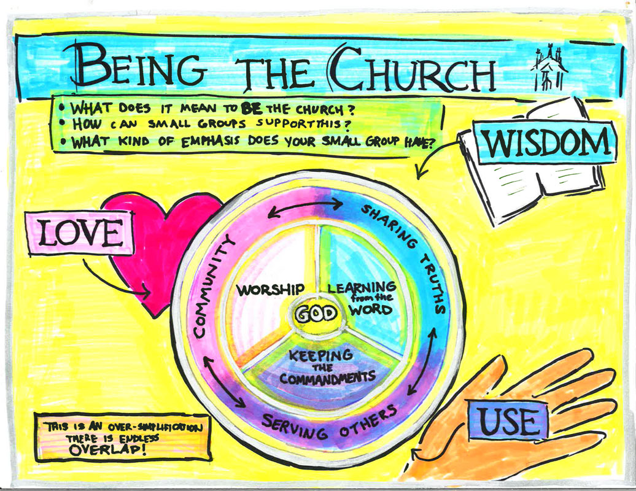
17

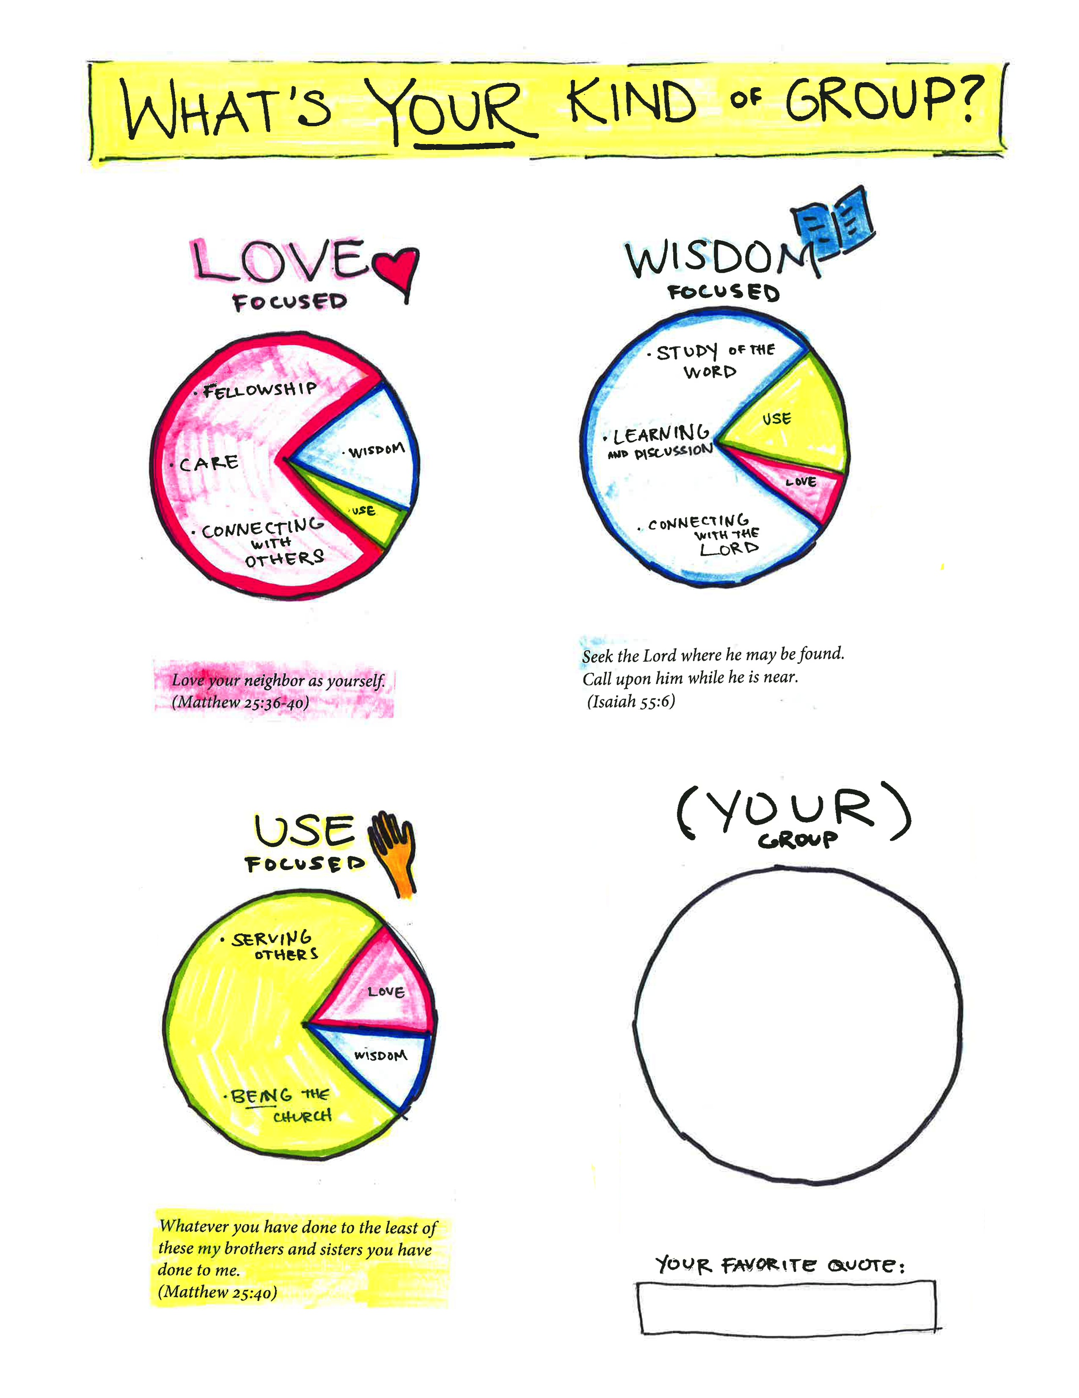

18

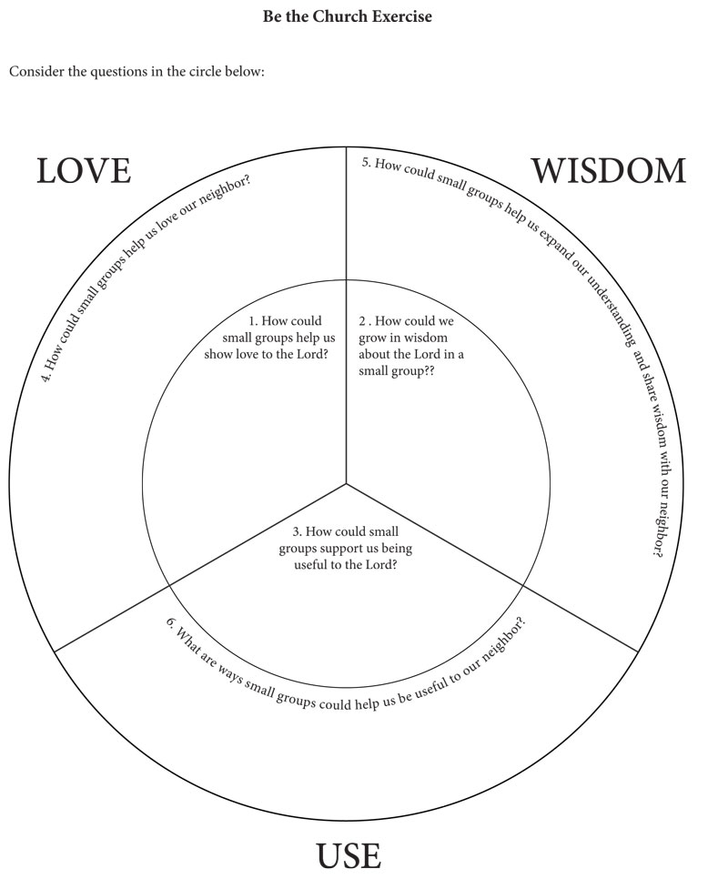
19

Icebreaker Ideas
Icebreakers get the group off to a good start.
- Icebreakers help people ease into the meeting.
- Icebreakers are fun and interesting ways for people to learn more about each other.
- Icebreakers encourage participants to talk in a lively, non-threatening way.
- Icebreakers help people move out of the busyness of the past week and move into the groups content.
A typical opening line is: “I have a question for everyone to answer…” The person asking an icebreaker question should serve as a model by answering first with one or two sentences. Then, go around the circle to each person. Don’t let anyone monopolize the question.
Although we usually think of icebreakers as a means to jumpstart a new class, even groups that have been meeting for a long time can benefit from them. An established class may not have patience for a “get acquainted” question but a simple “what happened this week?” could go a long way.

Get Acquainted
- What was the happiest moment of your life?
- The greatest compliment I ever received.
- The hardest thing I have ever done…
- Describe a typical Tuesday in your life.
- My favorite movie is…
- My idea of a great vacation is…
- The thing I most enjoy in my spare time is…
- What is your favorite time of day?
- What is your favorite spot in your home or yard?
- My favorite book is...
- Other ideas: ______________________________________________

_____________________________________________________________
20

Advanced
- One thing I really appreciate about my spouse or best friend is… .
- The gift I will never forget …
- Share one of your strengths and one of your weaknesses.
- What is the greatest regret of your life?
- Two things that bother me are…
- If you could not fail, what would you like to do?
- My greatest disappointment…
- People might be surprised to find out that I…
- You have been granted one hour with the leader of our country.
  - What question will you ask?
  - What advice will you offer?
- While I was growing up I saw God as…
- Other ideas: ______________________________________________

_____________________________________________________________

“How good and pleasant it is
when God’s people live together in unity!”
-Psalms 133:1

21

Ideas for Content

From New Church Connection Magazine
Available at www.NewChurchConnection.org

Many Ages, Similar Stages (6 weeks)
By Sasha Silverman, based on Donnette Alfelt’s book From the Top of the Yardstick
Issue 3.2013 “Life Evolves. Does Faith?”

Be of Good Cheer (7 weeks)
By Ethan McCardell, based on his book Be of Good Cheer
Issue 1.2013 “Overcoming Negativity”

You Can Believe! (9 weeks)
By Grant Schnarr, based on his book You Can Believe!
Issue 3.2011 “A New Christianity”

Explore Providence (5 weeks)
By Frank Rose, based on his book Reflections on Divine Providence
Issue 2.2010 “Grief and Acceptance”

Spiritual Freedom (5 weeks)
By Ray Silverman and Paul Rhodes, featuring videos on YouTube
Issue 3.2010 “Breaking Free from Addiction”

Is This Really in God’s Plan? (6 weeks)
By Bronwen Henry, based on readings from Divine Providence
Issue 2.2013 “God’s Presence in Suffering”

Transforming Communication (5 weeks)
By Bronwen Henry and Sasha Silverman
Issue 5.2010 “Navigating Family Relationships”
22

Steps of Life Change (5 weeks)
By Thane Glenn and Mark Pendleton
Issue 1.2011 “Salvation: An Active Process”

Paradox (6 weeks)
By John Odhner and Bronwen Henry
Issue 6.2012 “Making Peace with Paradox”

Prayer (7 weeks)
By Bronwen Henry
Issue 3. 2012 “Does Prayer Work?”

Forgiveness (7 weeks)
By Bronwen Henry
Issue 2. 2012 “Forgiveness”

Learning from Bible Characters Who Have Messed Up (6 weeks)
By John Odhner and Sasha Silverman
Issue 5.2011 “Coping with Failure”

Questions Jesus Asks (5 weeks)
By Bronwen Henry and Sasha Silverman
Issue 5.2011 “Doubt, Disbelief, and Dispair”

Explore the Psalms (5 weeks)
By Abigail Smith and Bronwen Henry
Issue 5.2009 “Dealing with Fear and Worry”

Gospel of John (6 weeks)
By Chuck Blair
Issue 1.2010 “Overcoming Stress and Finding Balance”

World Religions (5 weeks)
By Bronwen Henry
Issue 1.2012 “God is Not Only Christian”
23

The Afterlife (7 weeks)
By Abigail Smith and Bronwen Henry
Issue 4.2009 “Life After Death”

Angels in Training (6 weeks)
By Bronwen Henry, based on John Odhner’s “What Angels Do”
Issue 5.2012 “Heaven and Angels”

Have You Ever Thought About… (5 weeks)
By Michelle Chapin, featuring videos by Off the Left Eye
Issue 5.2013 “Compassionate Living”

New Church Journey Programs
Available on www.NewChristianResources.org

- Living Gratefully (7 weeks)
- “Be The Church (4 weeks)
- Practicing Mindfulness (5 weeks)
- Meditations on Compassions (4 weeks)
- New Church 101 (4 weeks)
- What Would Love Do?” (7 weeks)
- Seven Practices of Peace (7 weeks)
- The Path of Integrity (7 weeks)
- Shift: Small Changes. Big Difference (7 weeks)
- Pause: Make Space for God (7 weeks)
- Living Courageously (7 weeks)
- Building Healthy Relationships (7 weeks)
- The Journey to Freedom (8 weeks)
- New Church Foundations (7 weeks)
Additional Series
- “Begin a New Life” by Mark Pendleton
- “Rise Above It” by Ray an dStar Silverman
- Sunroom Videos (visit www.sunroomgroups.org)
24

“And let us consider how to stir up one another to love and good works, not neglecting to meet together, as is the habit of some, but encouraging one another.”
-Hebrews 10:24-25

25

